Assignment 2

Chin Zhe Jing, id = 22221970

19 September, 2022

## Starting with R-Markdown

In the following R-Markdown document some data are created followed by calculation of some summary statistics and display of graphical summaries. All the results are embedded for you in the report when you knit the document into a report.

The following R chunk creates a dataset in a vector and stores it in R’s memory using the name x. You will have been given some directions in how to adapt this dataset on Blackboard.

x = c(10, 23, 14, 12, 34, 26, 28, 24)

The mean of this data is

mean(x)

## [1] 21.375

The summary statistics (minimum, maximum, $Q_{1}$, median, mean and $Q_{3}$) obtained from the summary() function are:

# Insert your code here  
  
summary(x)

## Min. 1st Qu. Median Mean 3rd Qu. Max.   
## 10.00 13.50 23.50 21.38 26.50 34.00

The five number summary which uses Tukey’s method to estimate the lower and upper quartiles ( $Q_{1}$ and $Q_{3}$) is given below. Notice the small differences in these quartiles.

# Insert your code here  
  
  
fivenum(x)

## [1] 10.0 13.0 23.5 27.0 34.0

#minimum, lower-hinge, median, upper-hinge, and maximum

The boxplot of the data below also uses Tukey’s method. I would describe the shape of the distribution using the boxplot as left skewed.

boxplot(x)

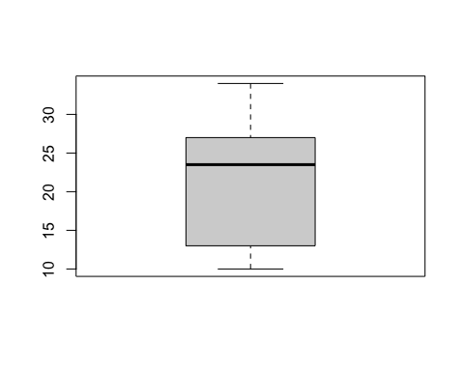

A histogram is given below. I would describe the shape of the distribution using the histogram as right skewed.

hist(x)

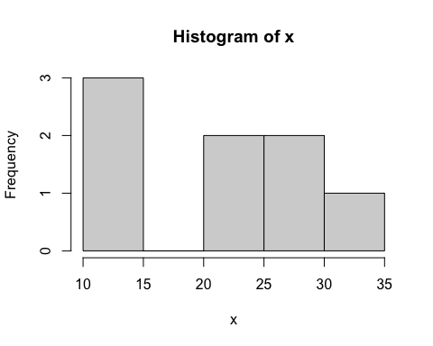

Use the help system in R to learn how to use the breaks argument in the hist function to include around 10 breakpoints. To use the help system type help(hist)

hist(x, breaks = 10)

